

# Leonard Lief Library

Languages and Literatures

present

A Reading and Discussion

# Les mascarades du Wisconsin

# by Thomas Spear

In a small Midwestern town that embodies the wholesome prosperity of the baby boom years, a foul-mouthed, wisecracking father rules over his brood. He is a gregarious eccentric who buried existential secrets when leaving behind his urban East Coast roots.

In this novel, one of his sons addresses his father directly and posthumously to uncover their shared heritage and expose the patriarchal myth. It is a story of social imperatives that constrain and define masculinity in the American Heartland and the son's resistance to a predetermined destiny.

**Thomas Spear** is Professor Emeritus of French in the Languages and Literatures Department at Lehman College

This Reading will be conducted in English.

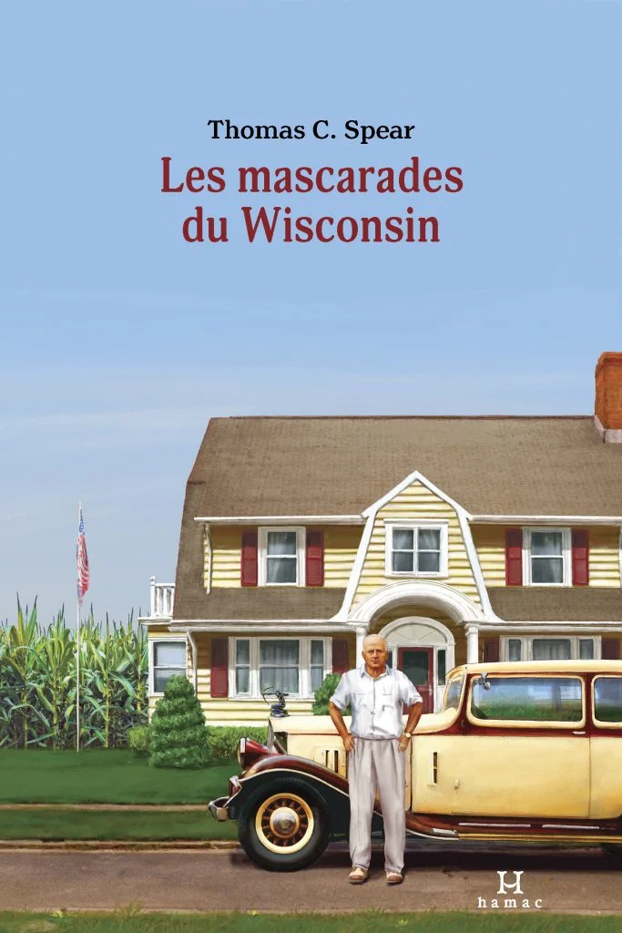

**Tuesday, November 19, 2024**

**1:00 - 2:00 PM**

RSVP by November 18th: <https://libcal.lehman.edu/event/13354622>

Location: Library - Treehouse Conference Room 317

*\*Registration is required\**

Information: [Vanessa.ArceSenati@lehman.cuny.edu](mailto:Vanessa.ArceSenati@lehman.cuny.edu)