How to Edit a Requisition that has Received a Budget Error?

BUSINESS OBJECTIVE: If funds are not available in the chartfield string, requisitions will fail the budget check process (see Budget Overview Query section). Requesters must contact the Budget Office to correct the error. Requisitions in budget error DO NOT route to the Purchasing Department.
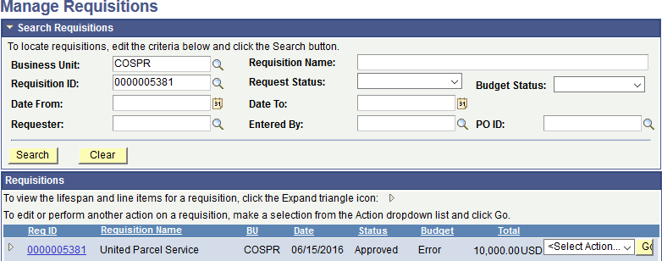
STEP#1: Navigate to eProcurement>Manage Requisitions and search for the requisition that is in Approved
Status and Budget Error.
Here is an example

STEP#2: ‘Select Action’ dropdown to the right of ‘Total’, select ‘Edit Requisition’ and click on GO to investigate the details of the error
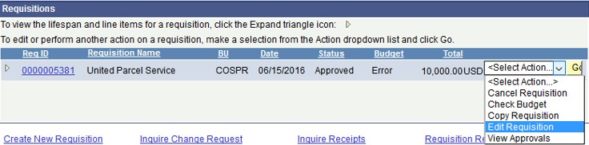

STEP#3: Read the message carefully. Click Ok

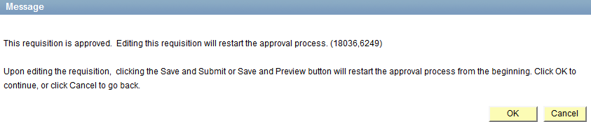
STEP#4: System indicates that current requisition has failed budget check, click OK. Click on the Error hyperlink
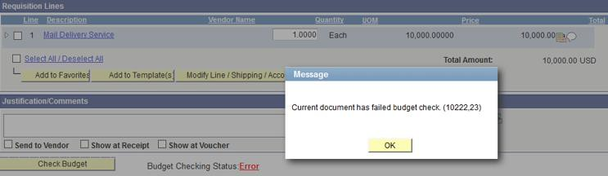

STEP#5: There are a few reasons why a requisition will fail the budget check process, this one reads ‘No Budget Exists’
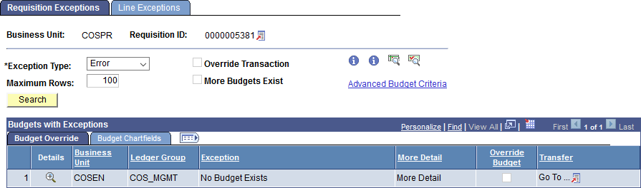

STEP#6: Click on the ‘Budget Chartfields’ tab to review all chartfields include Budgetary Account.
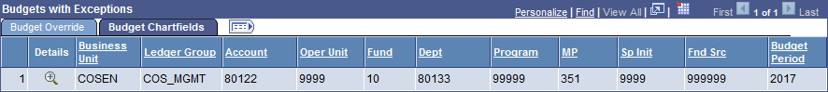
This is your budgetary Account

Verify budgetary account number and associated chartfields are the same as the one obtained when you ran the Budget Overview Query. If it is not, edit your requisition and select the appropriate category code (see section 2- creation requisitions, 2-add items and services, step#2. If it is, see below.

STEP#7: Forward screenshots of step#5 and step#6 to your Budget Office to resolve the issue.
STEP#8: In this example, the budget office indicated that there was insufficient funds in the account number. The budget office increased the funding in the account and requisition will automatically pass budget check at the next budget checking cycle (top of the hour)

In some cases, requisitions will fail budget check due to the incorrect chartfield combination. The Budget Office will provide guidance regarding the chartfield string to be used. After correcting the chartfield string, requesters must Save & Submit the requisition for approval again.

NOTE: Requisitions with budget errors will not route to the Purchasing department.

