Managing Requisitions

BUSINESS OBJECTIVE: Manage Requisitions page will enable you to view requisitions and track their progress from creation to payment. Most importantly this tool will advise budget status since a requisition with budget error status DOES NOT route to the Purchasing Department.
STEP#1: Navigate to eProcurement>Manage Requisitions

STEP#2: Enter as much information to locate the requisition to be reviewed. For example, Business Unit, ‘date from’ and ‘date to’ has been entered. Click Search.
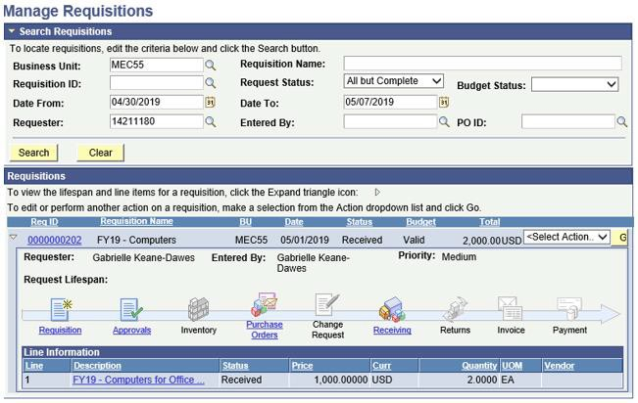

If the requester EMPLID does not default, enter it. Requesters can only manage their own requisitions. Unless they are Creators on behalf of a Requester(s).

In this example: requisition 0000000202 has been routed to the Purchasing Department where a Purchase Order has been created and the requestor has added a receipt. Requesters can track all changes to their requisitions from this page including approvals, managing budget status errors, copy and cancelling requisitions.

