Amount Only Requisition Lines
To make a line on a requisition an Amount Only line, click on the Line Details icon, place a check mark on
the Amount Only check box, click Ok and finally click on Yes.

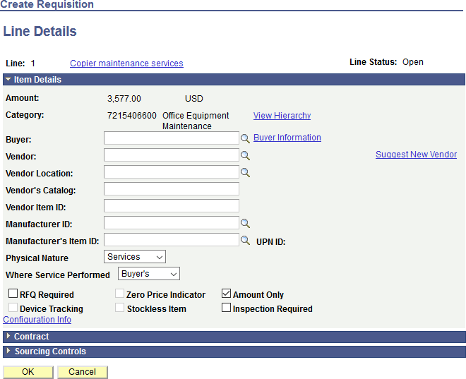
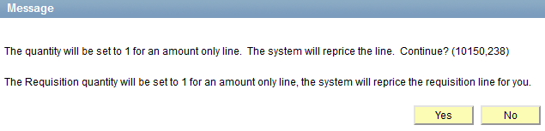
REMEMBER: Amount Only Lines on a requisition are for services only.
E.g. telephone bills, maintenance services, Etc.

Making an Amount Only requisition line offers flexibility to the requester when creating receipts

